Driver Drowsiness Monitoring System using Visual Behaviour and Machine Learning

Indhumathi.S,Assistant Srinidhi Kalluri, Student,
Professor, Department of Computer Department of Computer Science and
Science and Engineering- Artificial Engineering- Artificial Intelligence and
Intellingence and Machine Learning, Machine Learning,
Sphoorthy Engineering College, Sphoorthy Engineering College,
Indhumell@gmail.com kallurisrinidhireddy@gmail.com

Sneha Peraka,Student, Srujana Ponaganti, Student,
Department of Computer Science and Department of Computer Science and
Engineering- Artificial Intelligence and Engineering- Artificial Intelligence and
Machine Learning, Machine Learning,
Sphoorthy Engineering College, Sphoorthy Engineering College,
snehaperaka@gmail.com srujanareddy2607@gmail.com

Abstract—Drowsy driving is a leading cause of road accidents, particularly among long-distance truck and bus drivers. To enhance road safety, we propose a real-time, non-intrusive driver drowsiness detection system using a standard webcam. The system analyzes facial features via image processing and machine learning, offering a portable and affordable solution for fatigue monitoring. Existing drowsiness detection methods fall into three categories: vehicle-based, behavioral-based, and physiological-based. Vehicle-based methods analyze driving patterns, behavioral-based methods monitor visual cues such as eye closure and yawning, while physiological-based methods track biosignals such as EEG and heart rate.
In this paper, we propose a real-time, webcam-based drowsiness detection system that utilizes image processing and machine learning to analyze facial features. This approach ensures a non-intrusive, portable, and affordable solution for enhancing road safety.
KEYWORDS— driver drowsiness detection, image processing, machine learning, real-time monitoring, facial landmark analysis
I. INTRODUCTION
Road safety is a critical global concern, and drowsy driving has emerged as one of the major causes of traffic accidents, injuries, and fatalities. According to traffic safety reports, fatigue-related crashes are especially common among drivers who operate vehicles for extended hours, such as long-haul truck drivers and overnight bus drivers. Drowsiness impairs attention, slows reaction time, and reduces situational awareness—factors that significantly increase the likelihood of accidents. As a result, early detection of driver fatigue has become an active area of research, aiming to enhance driver safety and reduce accident rates.
Driver drowsiness detection systems are designed to monitor the driver’s state in real time and issue alerts when signs of fatigue are detected. Typically, such systems are structured into three primary modules: the acquisition system, which gathers input data such as video or physiological signals; the processing system, which analyzes the data to determine the driver’s alertness level; and the warning system, which triggers an alert if drowsiness is detected.
Current drowsiness detection methods are broadly categorized into three types:
1.Vehicle-based methods monitor driving behavior through parameters such as steering wheel movement, lane deviation, speed, and pedal usage. These are non-intrusive but can be influenced by road and vehicle conditions, potentially leading to false positives.
2.Behavioral-based methods rely on visual monitoring of facial features, including eye closure, blinking rate, yawning, and head movement. These methods are also non-intrusive and increasingly popular due to the availability of affordable camera technology and advancements in computer vision.
3.Physiological-based methods involve monitoring biosignals like Electroencephalogram (EEG), Electrooculogram (EOG), Electrocardiogram (ECG), heart rate, and pulse. While these methods offer high accuracy, they are intrusive, require direct contact with the driver, and often involve expensive hardware.
To overcome limitations of cost, comfort, and real-time use, this paper proposes a non-intrusive, webcam-based drowsiness detection system using image processing and machine learning to analyze facial features. The goal is to create an accurate, affordable, and real-time solution that issues timely warnings with minimal disruption to the driver, enhancing safety in both commercial and personal vehicles.
II. RELATED WORK
Driver drowsiness detection has been a significant area of research over the past few decades due to its direct impact on road safety. Numerous methods have been explored to mitigate the risk of accidents caused by fatigue, especially among long-distance truck and bus drivers. These methods are typically classified into three primary categories: vehicle-based, behavioral-based, and physiological-based detection systems. Each of these approaches has its own advantages, limitations, and applicability depending on factors such as system cost, accuracy, and user comfort.
A. Vehicle-Based Methods
Vehicle-based methods focus on analyzing the driver's control behavior and vehicle movement patterns. Metrics such as steering wheel angle, lane departure, acceleration and braking patterns, vehicle speed, and lateral position are continuously monitored to assess signs of drowsiness. Dong et al. [1] presented a system that used lane-keeping behavior and steering wheel corrections to detect drowsy driving patterns. These techniques are non-intrusive and do not require physical contact with the driver, making them ideal for integration into modern vehicles.
However, the accuracy of vehicle-based methods can be influenced by external factors such as road curvature, weather conditions, and traffic patterns. These systems may also require calibration for different vehicles and drivers, limiting their universality. Furthermore, they may detect anomalies unrelated to drowsiness, such as sudden maneuvers due to road obstructions, which could lead to false positives.
B. Behavioral-Based Methods
Behavioral-based systems analyze the driver’s facial expressions and movements using computer vision techniques. Common behavioral indicators of drowsiness include eye blink rate, duration of eye closure, yawning, gaze direction, and head nodding. Ji et al. [2] introduced a real-time monitoring system using infrared cameras to track eye movements and estimate fatigue. Bergasa et al. [3] developed a vision-based monitoring system capable of detecting eye closure and head orientation using feature extraction and face tracking.
These systems are non-intrusive, relatively low-cost, and can be implemented with a basic camera module and image processing algorithms. Advances in facial recognition and deep learning have significantly improved the robustness of these systems under varied lighting conditions and head poses. The PERCLOS metric (Percentage of Eyelid Closure over the Pupil over Time) has become a widely accepted standard for measuring fatigue in such systems.
Despite their effectiveness, behavioral methods can face challenges in poor lighting conditions, occlusion of the face (e.g., sunglasses), or incorrect camera placement. High computational demands for real-time video processing can also limit their deployment on resource-constrained devices without hardware acceleration.
C. Physiological-Based Methods
Physiological approaches use biological signals to determine the driver’s state of alertness. Commonly used signals include the Electroencephalogram (EEG), Electrooculogram (EOG), Electrocardiogram (ECG), pulse rate, and skin conductance. Picot et al. [4] demonstrated the use of EEG signals to classify various levels of alertness in drivers. These signals offer high accuracy and reliability, especially for capturing subtle variations in the driver’s mental state.
However, such methods are inherently intrusive as they require the driver to wear sensors or electrodes, often on the head, chest, or hands. This can cause discomfort, distraction, and resistance to usage in real-world scenarios. The associated hardware is also more expensive, and maintaining sensor contact quality over long periods is challenging, particularly in high-vibration environments like vehicles.
D. Machine Learning and Deep Learning Approaches
Recent research has focused on leveraging machine learning (ML) and deep learning (DL) algorithms to improve detection accuracy and reduce reliance on handcrafted features. Abtahi et al. [5] used a hybrid approach with Support Vector Machines (SVMs) trained on extracted facial features such as eye and mouth shape to detect yawning and prolonged eye closure. ML models can generalize well across different driver profiles if trained on diverse datasets.
Deep learning, particularly Convolutional Neural Networks (CNNs), has shown great promise in capturing complex patterns in image and video data. Khushaba et al. [6] proposed a fuzzy logic classifier with wavelet-transformed EEG signals, achieving high accuracy in drowsiness detection. More recently, Hossain et al. [7] demonstrated the effectiveness of CNNs in real-time drowsiness detection using facial landmarks and temporal features, even under varying environmental conditions.
The integration of ML/DL techniques offers the benefits of automatic feature extraction, adaptive learning, and the potential for real-time deployment on embedded platforms. However, such systems require large annotated datasets, robust training pipelines, and efficient models to operate reliably in real-world environments.
III.METHODOLOGY
The methodology for this project, titled Driver Drowsiness Monitoring System Using Visual Behavior and Machine Learning, is strategically divided into several well-structured stages. These stages include Data Acquisition, Preprocessing, Feature Extraction, Classification, and Alert Generation. Each phase has been carefully designed to ensure that the system is accurate, efficient, and capable of functioning in real-time scenarios
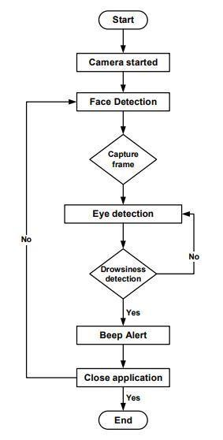
As shown in Fig. 1. Flowchart of the Real-Time Driver Drowsiness Detection Process
III.A. Data Acquisition
- The first step involves capturing live video of the driver’s face using a standard webcam or camera module placed on the vehicle dashboard, aligned with the driver's face. This setup is non-intrusive, cost-effective, and suitable for real-time monitoring. The camera continuously records the driver's facial expressions and eye movements under varying lighting and head-position conditions, ensuring robustness in real-world applications.
This module serves as the sensory unit of the system and is responsible for feeding real-time data into the processing pipeline. The decision to rely solely on visual data (instead of physiological sensors like ECG or EEG) was made to prioritize comfort, scalability, and affordability.
III.B. Preprocessing
The raw video frames obtained are preprocessed before being fed into the detection algorithm. Preprocessing steps include:
- Grayscale Conversion: Reduces computational complexity by eliminating color data.
- Frame Resizing: Maintains a uniform input size for faster and consistent processing.
- Noise Reduction: Enhances image quality by applying filters such as Gaussian Blur.
- Histogram Equalization: Improves contrast, especially under poor lighting conditions.
These steps prepare the video data for reliable facial feature detection and ensure that the machine learning model receives clean, consistent inputs.
III,C. Feature Extraction
The next step focuses on detecting and analyzing critical facial landmarks using techniques such as:
Haar Cascades or HOG + SVM for face and eye detection.
Dlib’s 68-point facial landmark detector for precise tracking of eyes, lips, and face shape.
From these features, behavioral indicators of drowsiness are extracted. Key metrics include:
Eye Aspect Ratio (EAR): Determines whether the eyes are open or closed. A sustained low EAR indicates eye closure.
Mouth Aspect Ratio (MAR): Used to detect yawning behavior, a known symptom of fatigue.
Blink Rate and Duration: Abnormally slow or frequent blinks signal drowsiness.
Head Position and Tilt: Sudden nodding or head drooping patterns are also monitored.
Nose Length Ratio (NLR): Variation in the perceived length of the nose can indicate head tilting or nodding, which are behavioral signs of drowsiness. A sudden apparent increase or decrease in nose length (in 2D camera view) often correlates with head movement like drooping or nodding forward, which is analyzed frame-by-frame to detect fatigue-related posture changes.
III.D. Classification (Detection Logic)
A machine learning algorithm is used to classify the driver's current state into either “alert” or “drowsy.” The model is trained on a labeled dataset containing annotated images and video clips of both awake and drowsy drivers. Classification models such as Support Vector Machines (SVM), Convolutional Neural Networks (CNN), or a custom logic-based system using threshold values of EAR and MAR are employed.
For example, if the EAR remains below a defined threshold for a certain number of consecutive frames, the system infers that the driver is falling asleep. Likewise, frequent yawns (high MAR) and slow blinks are used to reinforce the detection of fatigue.
Adaptive Thresholding: To account for individual differences and environmental variability (e.g., lighting), dynamic thresholds are used for EAR and MAR values. Instead of fixed values, the system adjusts thresholds based on initial calibration or running averages, improving robustness and minimizing false positives in diverse real-world conditions.
III.E.Alert Generation
Once the system detects drowsiness, it immediately triggers a warning mechanism to regain the driver’s attention. This includes:
Visual Warning: An on-screen message or flashing icon may appear if a display is integrated.
Optional Haptic Feedback: In advanced systems, steering wheel vibration or seat vibration can be triggered.
This preventive mechanism is designed to act instantly to avoid potential accidents due to delayed human reaction time.
3.6 System Design Considerations
The entire system is developed with considerations such as:
Low latency for real-time execution.
Lightweight algorithms suitable for deployment on embedded systems (e.g., Raspberry Pi).
Scalability to integrate with future advancements like GPS tracking and accident reporting.
Additionally, care is taken to ensure that the system does not generate frequent false alarms by setting dynamic thresholds based on environmental factors (like lighting) and driver-specific calibration.

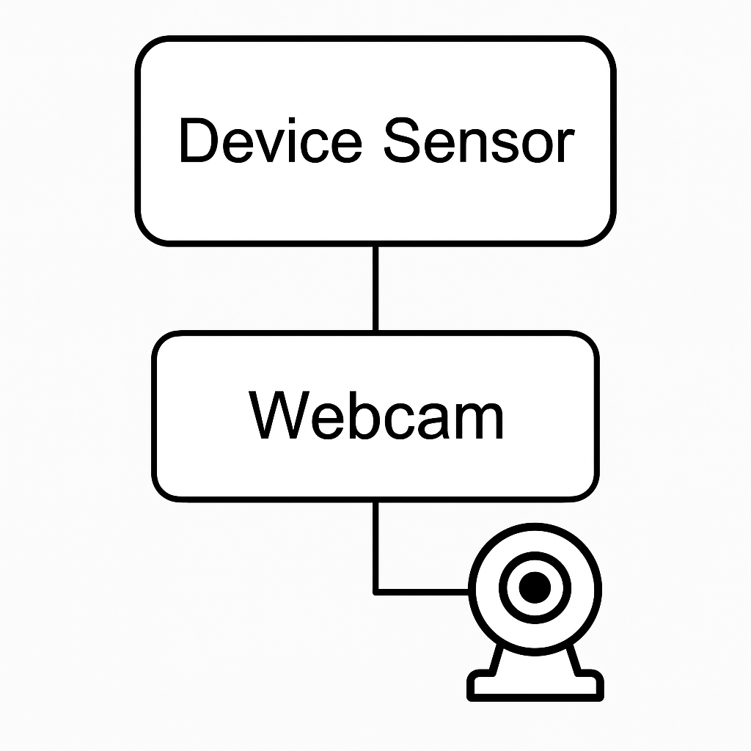
As shown in Fig. 2. System Architecture of the Driver Drowsiness Detection Device Using Webcam and Embedded Sensors

3.7 Test Cases Scenarios
Table I. Test Case Scenarios for Drowsiness Detection
Test Test Case ID | Scenario | EAR | MAR | Detected | Expected Result
TC01 | Eyes open | > 0.25 | < 0.65 | Alert | No warning
TC02 | Eyes closed (3s) | < .25 | < 0.65 | Drowsy | Audio alert
TC03 | Yawning | > 0.25 | > 0.65 | Drowsy | Audio alert
TC04 | Head tilt + blink | < 0.25 | ~0.65 | Drowsy | Audio alert
TC05 | Normal blinking | > 0.25 | < 0.65 | Alert | No warning
TC06 | Nose Ratio variation (fake face) | > 2 | Any | Not Detected | False detection prevented

IV.RESULTS AND OUTPUT SCREENS
Output Screens
To run this project double click on ‘run.bat’ file to get below screen
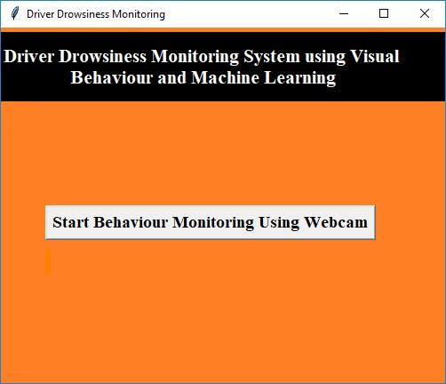
“When the ‘Start Behaviour Monitoring Using Webcam’ button is clicked, the system establishes a connection to the webcam. The interface displays a real-time video stream for facial feature extraction and drowsiness analysis, as shown in Fig. 3.”

In above fig.4. we can see web cam stream then application monitor all frames to see person eyes are open or not, if closed then will get below message
V.CONCLUSION
In this paper, a low-cost, real-time driver drowsiness monitoring system based on visual behavior and machine learning was proposed. Key visual features—eye aspect ratio, mouth opening ratio, and nose length ratio—were extracted from webcam video. An adaptive thresholding technique enabled robust real-time drowsiness detection. The system achieved high accuracy on synthetic data, with FLDA and SVM classifiers outperforming the Bayesian approach. FLDA and SVM achieved sensitivities of 0.896 and 0.956, respectively, with specificity of 1 for both. Future work includes integrating FLDA and SVM for real-time online classification, hardware implementation for in-vehicle use, and pilot studies for system validation.
REFERENCES
[1] T. Soukupová and J. Čech, “Real-time eye blink detection using facial landmarks,” in *Proc. 21st Computer Vision Winter Workshop*, Rimske Toplice, Slovenia, Feb. 2016, pp. 1–8.
[2] A. T. Ranganathan, S. V. B. R. Kumar, and L. Davis, “Driver fatigue detection using machine vision,” in *Proc. IEEE Conf. Intelligent Transportation Systems*, Toronto, ON, Canada, Sep. 2006, pp. 1184–1189.
[3] P. Viola and M. Jones, “Rapid object detection using a boosted cascade of simple features,” in *Proc. IEEE Conf. Computer Vision and Pattern Recognition*, Kauai, HI, USA, 2001, pp. 511–518.
[4] G. Bradski, “The OpenCV Library,” *Dr. Dobb’s Journal of Software Tools*, vol. 25, no. 11, pp. 120–126, 2000.
[5] C. M. Bishop, *Pattern Recognition and Machine Learning*, New York, NY, USA: Springer, 2006.
[6] S. Singh, A. Gupta, and R. Sharma, “Real-time driver drowsiness detection system using computer vision and machine learning,” *Int. J. Comput. Appl.*, vol. 182, no. 47, pp. 28–32, Apr. 2019.
[7] H. Wang and M. Yang, “Driver fatigue detection: A survey,” in *Proc. IEEE Int. Conf. Intelligent Transportation Systems*, Qingdao, China, Oct. 2014, pp. 1–6.
[8] D. P. King, “Dlib-ml: A machine learning toolkit,” *Journal of Machine Learning Research*, vol. 10, pp. 1755–1758, 2009.
[9] Y. LeCun, Y. Bengio, and G. Hinton, “Deep learning,” *Nature*, vol. 521, no. 7553, pp. 436–444, May 2015.

